192.168.3.0/ 255.255.255.0

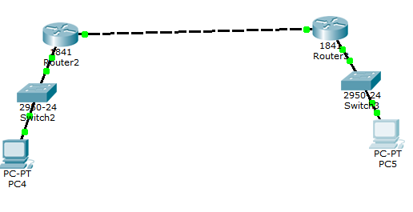

192.168.1.0/ 255.255.255.0 192.168.2.0/ 255.255.255.0

------------------------------------------------------------------------------------------------------------------------------------------

[dhcp]

192.168.3.0/ 255.255.255.0

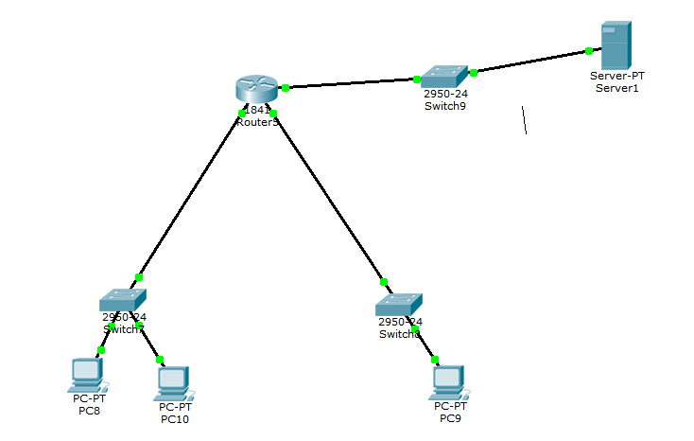

192.168.1.0 / 255.255.255.0 192.168.2.0 255.255.255.0